ProTenders: GCC hotel construction projects valued at $502bn

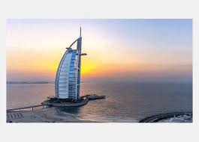
UAE-headquartered construction projects listings platform ProTenders has found that more than 1,110 hotel construction projects worth $502bn are at various stages of development in the GCC’s hospitality sector, with the UAE and Saudi Arabia accounting for 80% of the GCC’s active hotel projects’ value, followed by Oman and Kuwait, which together make up 44% of GCC hotel projects in the planning stage, as Bahrain remains the GCC’s smallest hospitality market with $16bn active projects.
ProTenders’ GCC Hospitality Construction Report 2019 found that the GCC’s pre-construction sector has a long-term pipeline comprising more than 400 hospitality projects worth $195bn, with 28% of these developments in the tender stage and valued at $53bn.
The UAE accounts for 43% of the GCC’s hospitality construction project value, with hotel developments worth $131.5bn, and Saudi Arabia – making up 42% of the GCC’s hotel construction project value – accounting for $128.6bn worth of projects.
Contract awards in the UAE’s hotel construction sector during H2 2019 are expected to be valued at “more than four times that of Saudi Arabia”, according to ProTenders.
The company said the UAE’s contract projections “are no surprise as developers and operators rush to finish projects in time for Expo 2020 Dubai beginning in October next year”.

